Midterm report

The core idea of this project was to understand the usage of SQL commands. And it was asked to write a python script for creating SQL tables. So I guess, I did what was told. Let me show all.

1. I installed my SQL server and workbench as i wanted to use my SQL.
2. I made some tables as required in the paper.

First I made drivers table and made it with 2 columns for beginning, and added more columns with the command Alter add. I really wanted to show my skills.

1. I did tables for trips and vehicles and officials as well with all the column names given. I made a common column for drivers and vehicles. It was the licence number. And the country and officials are connected each other with language column. See my scripts.

Here my screenshots of existing tables in my database.

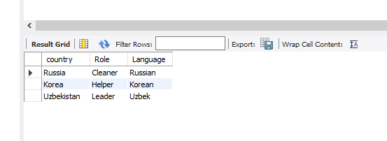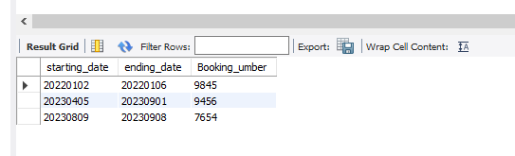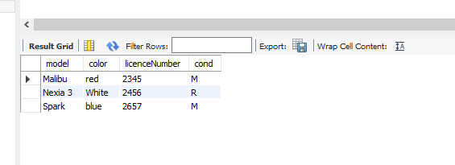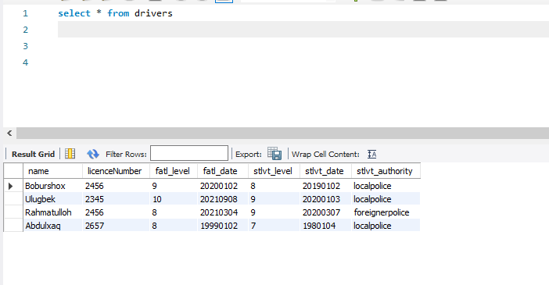

I MANUALLY INPUT THE DATA. SO THERE IS NO MUCH DATA AS MORE DATA INPUT TAKES SO LONG TIME.